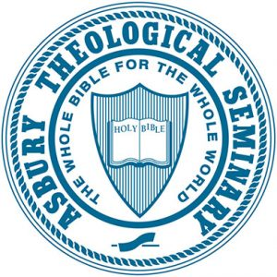

Asbury Theological Seminary Syllabus
DM (CPC)916B: Seminar Two: New Church Types and Networks: Case Studies
2.00 Credit Hours
Extended Learning/Online course
2020 Fall Session/Sep 8, 2020 – Dec 18, 2020
PROFESSOR INFORMATION

Name: Dr. Winfield Bevins
Title: Director of Church Planting
Email: winfield.bevins@asburyseminary.edu
Office Location: Beeson Center 130
Office Hours: Wednesday 3:00-4:00pm
Office Phone: 859.858.2388

Name: Dr. Bryan Collier
Title: Founding and Lead Pastor, The Orchard Church
Email: bryan.collier@asburyseminary.edu OR bryan@theorchard.net
Office Location: N/A
Office Hours: N/A

Name: Dr. Ed Love
Title: Director of Church Multiplication, The Wesleyan Church
Email: lovee@wesleyan.org
Office Location: N/A
Office Hours: N/A

COURSE DESCRIPTION

The second cohort seminar emphasizes both intensive and extensive orientation into the literature pertaining to the cohort's theme. Faculty mentors are tasked with creating exposure to significant theorists, schools of thought, normative and practical bodies of knowledge. Faculty mentors will require the completion of course learning exercises and projects, which are both relevant to the topic but which also advance the participant's ministry research project. Key Developmental Tasks: Conduct an extensive and representative literature survey related to your ministry research, and identify the key theme's which will help you analyze data that you will collect. Revisit and further document select leadership formation portfolio exercises and experiences.

PROGRAM LEARNING OUTCOMES (PLOs)
By the time students complete the D.Min. Program, they will have an accomplished or exceptional ability to:
1. Revisit foundations for sustainable ministry.
- Being immersed in explicit Wesleyan practices of community-based formation around the priorities of scripture, reason, tradition and experience, participants will discover transformational habits for sustainable ministry lifestyles.
2. Foster ministry leadership vision, ethic and practice relevant to their ministry context and world.
- By deeply engaging in analysis of one significant theme from their unique ministry context, participants establish a trajectory for life-long contribution.
3. Appreciate transformational demands within contemporary ministry organizational contexts such as congregations, non-profits and marketplace engagements through various analytic means of biblical, theological, social and cultural exegesis.
- Participants must add to their biblical and theological exegesis, cultural- situational exegesis that informs ministry leadership practice on a daily basis.
REQUIRED STUDENT LEARNING OUTCOMES
By the end of DM(CPC)916A, students will have an accomplished to exceptional ability to:
- Demonstrate they are conversant with key church planting philosophies, methods, genres, and networks, as well as a range of informed perspectives on their strengths, weaknesses, and potential. (PLO #1, #2)

- Reflect critically and interact analytically with course readings, lectures, discussions, and case studies vis-à-vis contemporary church planting methods and genres by offering opinions, careful assessments, and constructive recommendations. (PLO #2, #3)

- Conduct case study research of contemporary church plants and networks and through it demonstrate up-to-date knowledge of the field, analytic competency, and proficiency in developing appropriate recommendations and strategies for improvements in church planting effectiveness. (PLO #3)

ADDITIONAL STUDENT LEARNING OUTCOMES

N/A

COURSE INTRODUCTION

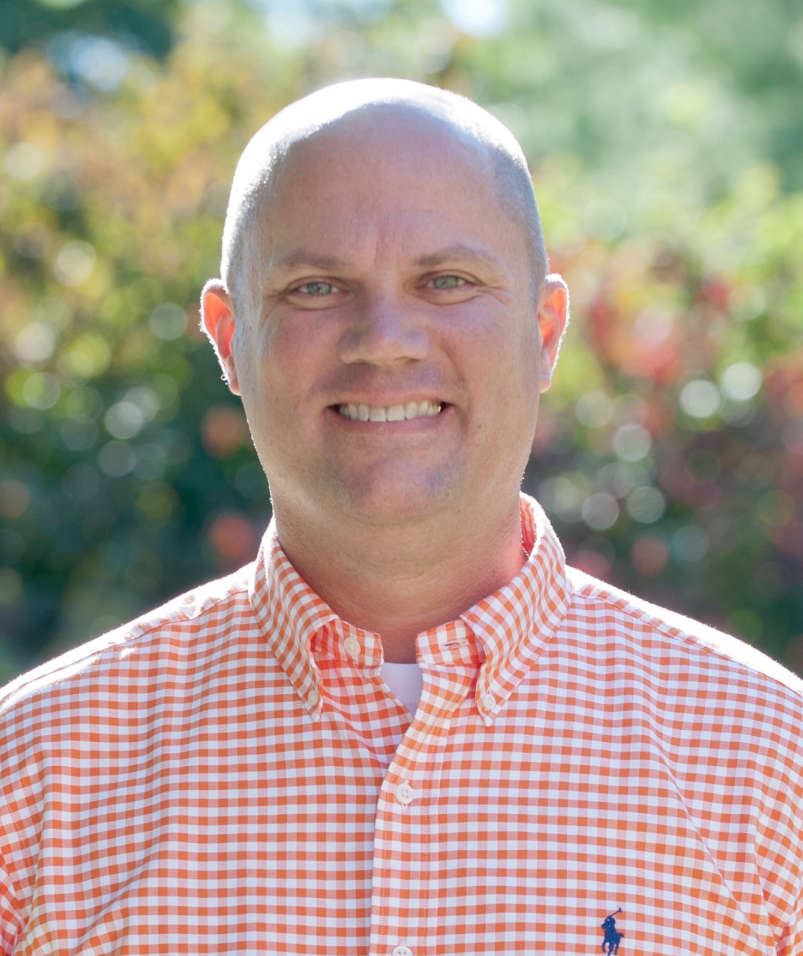

Welcome to New Church Types and Networks: Case Studies! The information below provides an introduction to your teaching team.
Winfield Bevins, D.Min. Winfield Bevins is the Director of Church Planting at Asbury Theological Seminary. He is an adjunct professor and guest lecturer at various seminaries and universities in the United States and England. He has a Doctor of Ministry from Southeastern Seminary in Wake Forest and is pursuing a PhD at the University of Aberdeen, Scotland. He is a visiting Scholar at the National Institute for Newman Studies, Duquesne University. Having grown up in a free-church background, Winfield eventually found his spiritual home in the Anglican tradition, but freely draws wisdom from all church traditions.
Winfield is the author of several books, including Marks of a Movement: What the Church Today Can Learn from the Wesleyan Revival; and Ever Ancient Ever New: The Allure of Liturgy for a New Generation; Creed: Connect to the Essentials of Historic Christian Faith; Our Common Prayer: A Field Guide to Common Prayer; Grow at Home; and Church Planting Revolution. He has published articles in various publications including Liturgy, The Wesleyan Theological Journal, The Asbury Theological Journal, Pneuma Review, The Journal of Pentecostal Theology, and Christianity Today.
As a seasoned practitioner, he has helped plant several churches and has used his experience to train leaders from around the world. He is also a visual artist who enjoys painting iconography, landscapes, and portraits. Over the past decade, he has helped start numerous arts initiatives, including a non-profit art gallery and studio, and an arts program in North Carolina. He and his wife Kay live in Wilmore, Kentucky and have three daughters; Elizabeth, Anna Belle, and Caroline.
Bryan Collier, D.Min. Dr. Collier is the Founding Pastor and also the Lead Pastor and Ministry Coach at The Orchard in Tupelo, Miss. Prior to planting The Orchard, he served four pastorates in Mississippi and Kentucky.
He began his Master of Divinity at Asbury Theological Seminary in the fall of 1991 and while serving pastorates in Kentucky, and earned his degree in the spring of 1994. Receiving a Beeson Fellowship Grant in 1997, his research focus was in the arena of systems theory and its impact as a tool of the leader. Collier adapted much of MIT Professor Peter Senge’s seminal work, The Fifth Discipline: The Art and Practice of The Learning Organization for church use.
Collier has more than 20 years of experience in pastoral ministry. His interests and expertise includes leadership issues, church for the un-churched and cultural dissection. He is passionate about helping people at all stages of faith grow deep in the love of God and branch out to others with that love. His passion extends to helping leaders and organizations facilitate this growth. To that end he is the author of Becoming An Orchard, Xulon Press, 2006; Gentle Interventions, Xulon Press, 2008; and The Go-To Church, Abingdon Press, 2013.
Collier is a sports enthusiast, a voracious reader and enjoys hiking and the outdoors. He is married to Wendy and they have a daughter, Olivia, and a son, Houston.
Ed Love, D.Min. is currently the Director of Church Multiplication for The Wesleyan Church, where he oversees the Church Multiplication Collective. Dr. Love has planted two multiplying churches, daughtered multiple church plants, and has provided coaching, training, and resources for church planters. Love also designed and teaches the church planting courses at Wesley Seminary. He received his M.Div. from Asbury Theological Seminary and obtained his D.Min. from George Fox Evangelical Seminary. Love is the author of Fear Not, Reclaiming Hope, Turn, and many other church multiplication resources. Love and his wife Emily reside in Muncie, IN with their three spunky kids, Jennah, Josiah, and Micah.
REQUIRED TEXTBOOKS
All texts should be read before the first day of class.
Bevins, Winfield. Church Planting Revolution: A Guidebook for Explorers, Planters, and Their Teams. Seedbed: 2017. (124 pages)
Not available in hard copy.
$12.95 Kindle, ASIN: B07545TRJP
Branson, Mark and Nicholas Warnes. Starting Missional Churches: Life with God in the Neighborhood. IVP Books: 2014. (192 pages)
$19.26 Paperback, ISBN: 978-0830841165
$9.99 Kindle, ASIN: B00HUCPX8A
Hirsch, Alan. The Forgotten Ways: Reactivating Apostolic Movements. 2nd ed. Brazos Press: 2016. (384 pages)
$14.17 Paperback, ISBN: 978-1587433863
$9.99 Kindle, ASIN: B01L9IVGMC
Moynagh, Michael, and Philip Harrold. Church for Every Context: An Introduction to Theology and Practice. SCM Press: 2012. (512 pages)
$43.52 Paperback, ISBN: 978-0334043690
$41.74 Kindle, ASIN: B008S965B8
Payne, J.D. Missional House Churches: Reaching Our Communities with the Gospel. IVP Books: 2008. (197 pages)
$17.00 Paperback, ISBN-13: 978-0830857067
Not available in Kindle format.
Snyder, Howard. The Problem of Wineskins. 40th anniversary ed. Seedbed Publishing: 2017. (214 pages)
$18.95 Paperback, ISBN-13: 978-1628243390
$18.95 Kindle, ASIN: B074QLQN38
Surratt, Geoff, Greg Ligon, and Warren Bird. The Multi-Site Church Revolution: Being One Church in Many Locations (Leadership Network Innovation Series). Zondervan: 2009. (224 pages)
$14.77 Paperback, ISBN: 978-0310270157
$7.99 Kindle, ASIN: B000SEQ6KQ
Watson, Kevin. The Class Meeting: Reclaiming a Forgotten (and Essential) Small Group Experience. Seedbed Publishing: 2013. (129 pages)
$17.47 Paperback, ISBN: 978-1628240580
$10.99 Kindle, ASIN: B00GXBBM7U
Total Pages: 1,976
REQUIRED RESOURCES

N/A
RECOMMENDED TEXTBOOKS
Hunter III, George G. The Celtic Way of Evangelism. 10th revised ed. Abingdon Press: 2010. (168 pages)
$13.99 Paperback, ISBN: 978-1426711374
$9.99 Kindle, ASIN: B004IPPEYU
RECOMMENDED RESOURCES

N/A

ASSIGNMENTS

To successfully complete this class, students must satisfactorily complete and submit all assignments on time and actively participate and contribute to the learning community.
1. Dissertation Status Report (20 points)
Due Date: September 15, 2020
Points/Percentage: 20
Learning Outcome: 1 & 2
Complete the Dissertation Status Report that is provided for you in your online classroom. This is an easy one, folks; just upload the completed form on time, and earn all 20 points!
- 1 day late = 18 points
- 2 days late = 15 points
- 3 days late = 12 points
- 4 days late = 10 points
- 5 days late = 5 points
- 6 or more days late = 0 points
2. Case Study Paper (80 points)
Due Date: October 25, 2020
Points/Percentage: 50
Learning Outcome: 3
This 12 to 15-page case study paper is to be a comparison of two or three case studies of same-genre of church planting or church plants.
The first half of the paper will describe and compare the cases, highlighting similarities and differences, and offering brief SWOT-style analyses of them.
Then, in the second half of the paper, you will analyze the genre itself: e.g., where and why it works and doesn’t, how strategic it is or isn’t in 2016 and/or in particular settings or situations. Choose a church planting genre that reflects your own experience, ministry expectations, or special interest. Let it serve as a tool for your dissertation research.
This paper should reflect new insights from the course readings and experiences.
Assignments
Assignment Description | SLO | Method of Assessment | Value /Due Date | Evaluator
Assignment #1: Dissertation Status Report | #1, 2 | Completed report form | 20%  Due: 9/15/2020.  Upload to online classroom. | Faculty
Assignment #2: Case Study Paper | #3 | 12-15 page case study paper | 80%  Due: 10/25/2020.  Upload to online classroom. | Faculty

ADDITIONAL ASSIGNMENT GUIDELINES

See below.

Student Learning Outcomes | Method of Assessment | Exemplary=4 | Accomplished=3 | Developing=2 | Beginning=1 | Evaluator
SLO #3: Conduct case study research of contemporary church plants and networks and through it demonstrate up-to-date knowledge of the field, analytic competency, and proficiency in developing appropriate recommendations and strategies for improvements in church planting effectiveness. | Case Study Paper | Conduct case study research, at an exemplary level, of contemporary church plants and networks and through it demonstrate up-to-date knowledge of the field, analytic competency, and proficiency in developing appropriate recommendations and strategies for improvements in church planting effectiveness. | Conduct case study research, at an accomplished level, of contemporary church plants and networks and through it demonstrate up-to-date knowledge of the field, analytic competency, and proficiency in developing appropriate recommendations and strategies for improvements in church planting effectiveness. | Conduct case study research, at a developing level, of contemporary church plants and networks and through it demonstrate up-to-date knowledge of the field, analytic competency, and proficiency in developing appropriate recommendations and strategies for improvements in church planting effectiveness. | Conduct case study research, at a beginning level, of contemporary church plants and networks and through it demonstrate up-to-date knowledge of the field, analytic competency, and proficiency in developing appropriate recommendations and strategies for improvements in church planting effectiveness. | Faculty

Attendance/Participation: To progress satisfactorily and achieve learning outcomes in this class, students must meet the course requirements. Students are responsible for notifying instructors of the reason for any absences as soon as possible and are accountable for all assignments. Makeup quizzes or exams are generally not permitted unless previously arranged with the instructor. Each faculty member will provide a written attendance policy for each class and also go over that policy on the first day of class for the course. Refer to the ATS Student Handbook for additional information regarding attendance policies and excused absences.
Late Assignments: Any assignment submitted after the due date and time will be reduced two numerical points for every day late. For example, two days late would reduce the grade from a 90 to an 86, unless the student talks to the professor ahead of time and receives permission to turn in the assignment late, based upon a legitimate excuse (such as illness).
Format of Papers: Students must use MLA academic style for completing papers; this is also the required style for your dissertation.
INCOMPLETE WORK POLICY
Incomplete Work: “A grade of ‘I’ denotes that course work has not been completed due to an unavoidable emergency. Delinquency or attending to church work or other employment does not constitute an unavoidable emergency. Without an approved ‘I,’ a letter grade will be recorded based on grades received for completed work and an ‘F’ grade assigned to incomplete work” (ATS 2015-16 Student Handbook, page 67).
Letter | Lowest | Highest
A | 94.00% | 100.00%
A- | 90.00% | 93.99%
B+ | 87.00% | 89.99%
B | 84.00% | 86.99%
B- | 80.00% | 83.99%
C+ | 77.00% | 79.99%
C | 74.00% | 76.99%
C- | 70.00% | 73.99%
D+ | 67.00% | 69.99%
D | 64.00% | 66.99%
D- | 60.00% | 63.99%
F | 0.00% | 59.99%
The unit of credit is a semester hour, which is defined as one hour of classroom work per week for one semester, or its equivalent. The 4.00 point system is used to compute grade point standing. The grading system is:
GRADE | EVALUATION CRITERIA
A | Exceptional work: surpassing outstanding achievement of course objectives
B | Good work: strong, significant achievement of course objectives
C | Acceptable work: basic, essential achievement of course objectives
D | Marginal work: inadequate, minimal achievement of course objectives
F | Unacceptable work: failure to achieve course objectives

GRADING

Assignment | Weight/Point Value
Dissertation Status Report | 20
Case Study Paper | 80
 | Total: 100

CANVAS (LEARNING MANAGEMENT SYSTEM)
Canvas is the learning management system used for Asbury seminary classes. Log into http://connect.asburyseminary.edu and click on the flashing cube (upper right corner) to access a link to the Canvas website. Once you have logged in, it is recommended that you bookmark this page for easy access. The courses that you are enrolled in should appear as “course cards” on your Dashboard. You may navigate to your desired course here. If you do not see your course, or there is nothing in your course, please contact your professor.

COURSE EVALUATIONS

Course evaluations are a vital part of Asbury Seminary’s efforts to achieve excellence in the classroom. At the end of the semester, you will receive an email with information and directions for completing course evaluations. Your responses are completely anonymous, and your participation is greatly appreciated. If you have questions or encounter problems accessing the evaluations, contact the Help Desk at helpdesk@asburyseminary.edu or by phone at 859.858.2100 or toll-free at 800.2ASBURY.

TECHNOLOGY REQUIREMENTS & SUPPORT
To take an online or hybrid class, you should be comfortable using e-mail, web browsers, word-processing software and be able to download files and create attachments. You will need the following in order to participate online:
- A computer with Windows 7 or MAC OS 10.6 or above
- An account with or regular access to an internet service provider (ISP)
- Reliable, high-speed internet (recommended)
- Word processing software
- A webcam (built-in or external) for video conferences, as needed
- A headset with microphone (preferable)
Contact the Help Desk for technical assistance accessing the online class, using electronic resources, or with other technical issues related to Asbury Seminary coursework.
- Email: helpdesk@asburyseminary.edu
- Phone: 859.858.2100 or 800.2ASBURY (toll free)
LIBRARY RESOURCES
Library resources, research support, and library loan are available via:
- Website: asbury.to/library
- Email: helpdesk@asburyseminary.edu
- Phone: 859.858.2100 or 800.2ASBURY (toll free)
Materials Requests
Use the links on the library website to search the library catalog for available materials. Students on the Kentucky or Florida campuses can use their student ID cards to check out materials in person. Books can be returned or mailed to the library at either the Kentucky or Florida campus.
Students may request books, photocopies, or emailed attachments of journal articles or portions of reference books from the library. Allow 3-10 business days for requests to be filled. Contact the library for costs and instructions on how to make requests, or view the online tutorial at guides.asburyseminary.edu/libraryloan.
Online Resources
- Asbury Scholar – Find library books, ebooks, journal articles, and other media at asbury.to/library.
- Databases – Access links to online resources including the library catalog, online journal databases, encyclopedias, and more at guides.asburyseminary.edu/az.php.
Research Assistance
Students should contact Research Services in the library for research assistance. Help is available for general research questions, including how to find course materials online or navigate library resources. Training for supported Bible software or bibliographic management software is also available. Appointments can be made via:
- Website: asbury.to/library
- Email: helpdesk@asburyseminary.edu
- Phone: 859.858.2100 or 800.2ASBURY (toll free)
The Writing Center
- The goal of the Writing Center is to help students improve their graduate-level writing. Assistance is available both online and on the Kentucky campus to help with various aspects of the writing process, including structure and organization, grammar, punctuation, and citation formatting. Appointments can be made by contacting the library via:
  - Website: asbury.to/writingcenter
  - Email: helpdesk@asburyseminary.edu
  - Phone: 859.858.2100 or 800.2ASBURY (toll free)
- Students can sign up for 30-minute sessions on the library website at asbury.to/library.
POLICIES
Each student is responsible for being familiar with seminary policies. Asbury Seminary reserves the right to change policies when necessary. Below are brief descriptions of a few seminary policies. For more detailed information regarding school policies, please refer to the ATS Student Handbook at asburyseminary.edu/students/student-services/student-handbook/
Disability Accommodations
Asbury Theological Seminary provides reasonable accommodation on an individualized basis for qualified students with disabilities. Students are required to provide documentation of a disability prior to receiving classroom accommodations. Since accommodations may require early planning before or at the start of the term and are generally not provided retroactively, students need to contact an Accommodations Officer as soon as possible. If you are a student with a disability and believe you require reasonable accommodations in this class, you will need to make an appointment with an Accommodations Officer in the Office of the Registrar on the Kentucky campus or in the Enrollment Management Office on the Florida campus. Students attending the Tennessee site should contact the Kentucky Registrar.
Academic Integrity
Academic integrity is expected of every student. Plagiarism, that is, “presenting … another’s ideas or writings as one’s own,” is considered a serious violation of integrity and is unacceptable. Detailed information, including the penalty for plagiarizing, is in the Student Handbook. For additional information about plagiarism, go to plagiarism.org.
In this course we may utilize Unicheck, an automated system that compares students’ assignments with websites as well as a database of previously submitted student work. After the assignment is processed, instructors receive a report from unicheck.com (through SpeedGrader™) that states if and how another person’s work was used in the assignment. For more information, see www.unicheck.com. If you have questions about academic honesty, please contact the library at helpdesk@asburyseminary.edu.
Copyright Information
The copyright law of the United States (title 17, United States Code) governs the making of photocopies or other reproductions of copyrighted material. Under certain conditions specified in the law, libraries and archives are authorized to furnish a photocopy or other reproduction. One of these specific conditions is that the photocopy or reproduction is not to be "used for any purpose other than private study, scholarship, or research." If a user makes a request for, or later uses, a photocopy or reproduction for purposes in excess of "fair use," that user may be liable for copyright infringement. This institution reserves the right to refuse to accept a copying order if, in its judgment, fulfillment of the order would involve violation of copyright law.
By using online media resources, students are consenting to abide by this copyright policy. Any duplication, reproduction, or modification of this material without express written consent from Asbury Theological Seminary and/or the original publisher is strictly prohibited.
ZOOM
Courses may use Zoom for synchronous online instruction. These sessions may be recorded by the professor and posted into the Canvas classroom. The recorded sessions will not be downloadable, and will not be used by the professor in future classes unless there is documented permission from all of the students in the recording. Chat rooms in a Zoom call are recorded and discretion should be exercised when using the chat feature, including in private rooms.
Video recordings may be considered educational records under the Family Education Rights & Privacy Act (FERPA) and will be protected as such by the Seminary. Zoom collects only minimal client information and ensures that information is kept secure (https://zoom.us/docs/doc/FERPA%20Guide.pdf).
Requests for accessibility accommodations related to Zoom will be dealt with on a case-by-case basis as described above under Disability Accommodations.
APPENDIX

N/A

